Cylinder
# Source: AI Source: Provided by: [Data Path: Persons Table -> ID Column: 1, Name_En Column: Motasem Essam] -> From: [ChatGPT] on [7/25/2026]
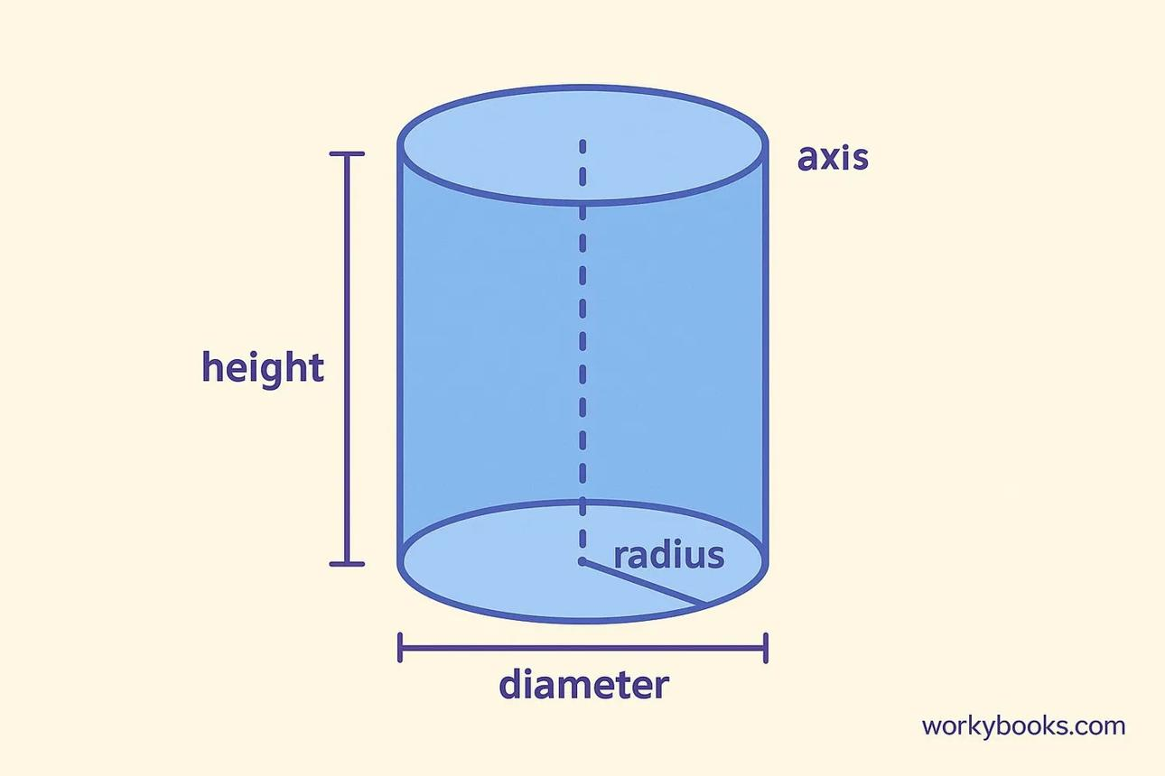

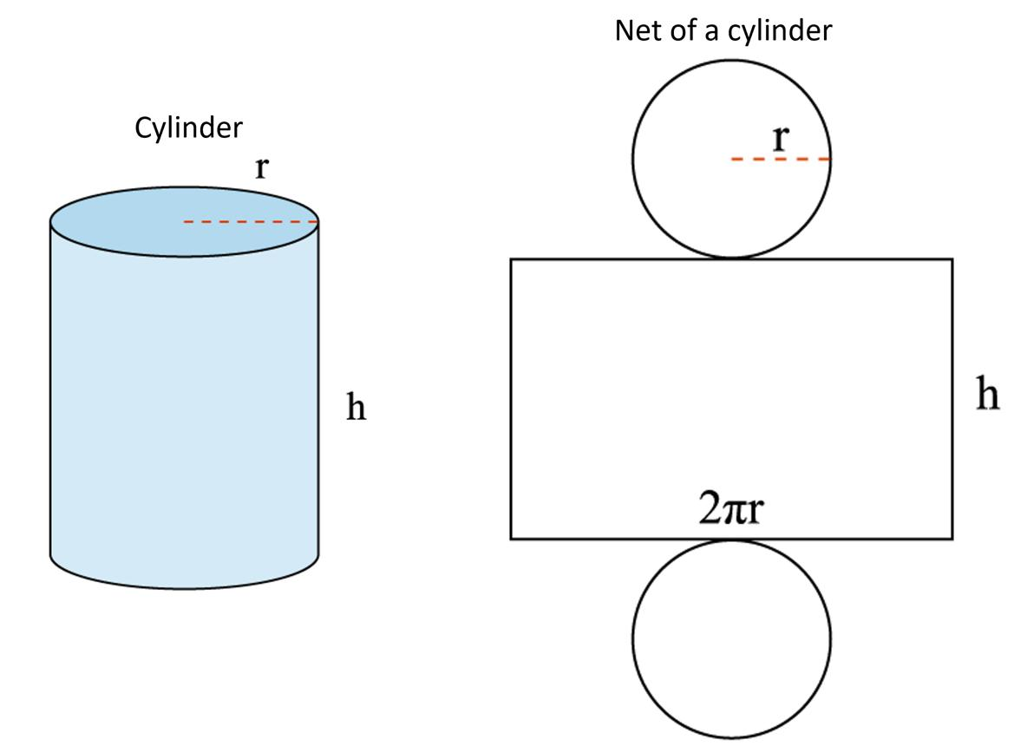

Definition
# Source: AI Source: Provided by: [Data Path: Persons Table -> ID Column: 1, Name_En Column: Motasem Essam] -> From: [ChatGPT] on [7/25/2026]
A cylinder is a three-dimensional geometric solid with two congruent, parallel bases connected by a curved lateral surface. In the common case of a right circular cylinder, the bases are equal circles, and the axis joining their centers is perpendicular to the base planes.
A cylinder has a curved lateral surface and two flat circular faces. Unlike a polyhedron, it does not have polygonal faces or straight edges around its curved side.

Simple Definition
# Source: AI Source: Provided by: [Data Path: Persons Table -> ID Column: 1, Name_En Column: Motasem Essam] -> From: [ChatGPT] on [7/25/2026]
A cylinder is a solid with two equal, parallel circular bases joined by a curved surface.
Examples include a tin can, a straight pipe, and a cylindrical container.

Key Characteristics
# Source: AI Source: Provided by: [Data Path: Persons Table -> ID Column: 1, Name_En Column: Motasem Essam] -> From: [ChatGPT] on [7/25/2026]
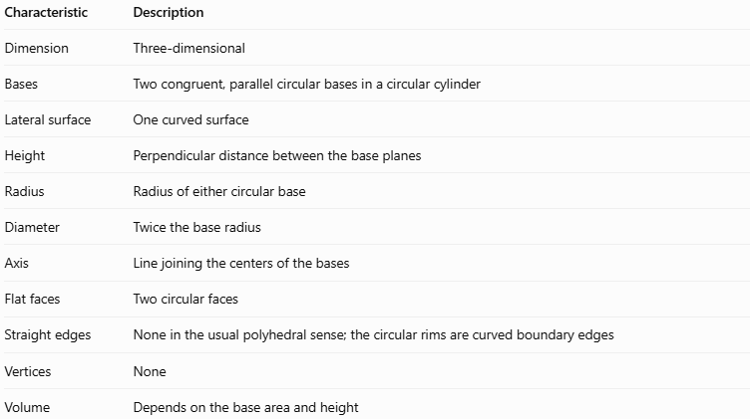
Characteristic | Description
Dimension | Three-dimensional
Bases | Two congruent, parallel circular bases in a circular cylinder
Lateral surface | One curved surface
Height | Perpendicular distance between the base planes
Radius | Radius of either circular base
Diameter | Twice the base radius
Axis | Line joining the centers of the bases
Flat faces | Two circular faces
Straight edges | None in the usual polyhedral sense; the circular rims are curved boundary edges
Vertices | None
Volume | Depends on the base area and height

Geometric Representation
# Source: AI Source: Provided by: [Data Path: Persons Table -> ID Column: 1, Name_En Column: Motasem Essam] -> From: [ChatGPT] on [7/25/2026]
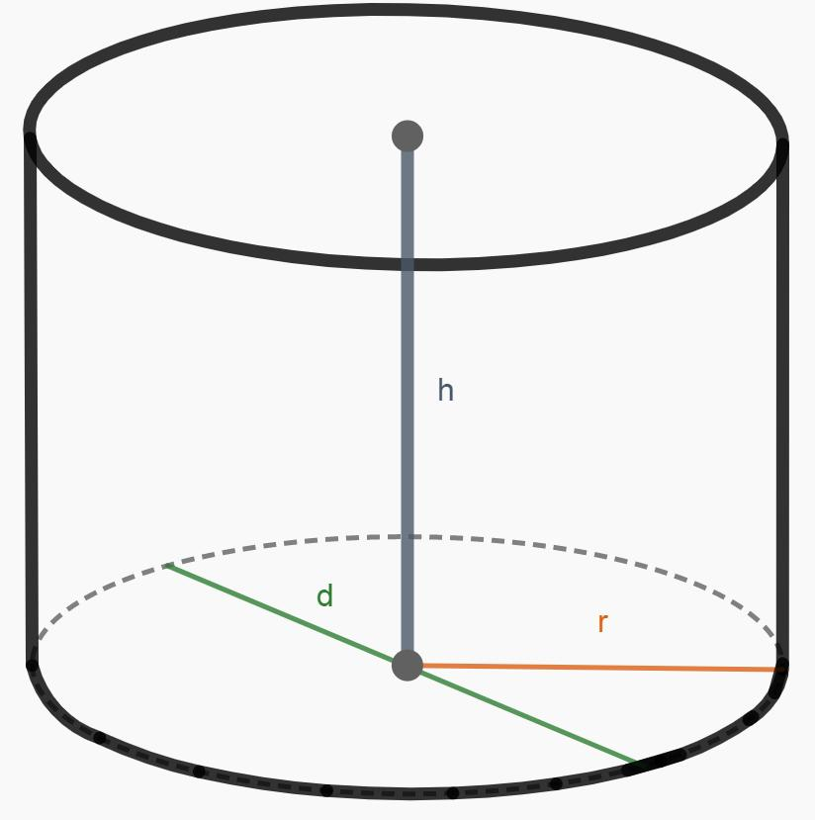
The main components of a cylinder are:
- Top base: The upper circular face.
- Bottom base: The lower circular face, congruent and parallel to the top base.
- Curved lateral surface: The curved boundary joining the two bases.
- Radius ($r$): Distance from the center of a circular base to its circumference.
- Diameter ($d$): Distance across a base through its center.
- Height ($h$): Perpendicular distance between the base planes.
- Axis: The line joining the centers of the bases.
- Circular rims: The circular curves where the lateral surface meets the bases.
The diameter and radius are related by:
$$\boxed{d=2r}$$
For a right circular cylinder, the axis is perpendicular to the bases, and the height equals the length of the axis between them.

6. Mathematical Representation and Formulas
# Source: AI Source: Provided by: [Data Path: Persons Table -> ID Column: 1, Name_En Column: Motasem Essam] -> From: [ChatGPT] on [7/25/2026]
The following formulas apply to a right circular cylinder, unless otherwise stated.

A. Base Area
# Source: AI Source: Provided by: [Data Path: Persons Table -> ID Column: 1, Name_En Column: Motasem Essam] -> From: [ChatGPT] on [7/25/2026]
Each base is a circle:
$$\boxed{B=πr^{2}}$$

B. Volume
# Source: AI Source: Provided by: [Data Path: Persons Table -> ID Column: 1, Name_En Column: Motasem Essam] -> From: [ChatGPT] on [7/25/2026]
The volume is the base area multiplied by the perpendicular height:
$$V=Bh$$
Therefore,
$$\boxed{V=πr^{2}h}$$

C. Curved Surface Area
# Source: AI Source: Provided by: [Data Path: Persons Table -> ID Column: 1, Name_En Column: Motasem Essam] -> From: [ChatGPT] on [7/25/2026]
When the curved surface is unrolled, it forms a rectangle with width equal to the circumference of the base and height $h$.
$$A_{L}=\left(2πr\right)h$$
Therefore,
$$\boxed{A_{L}=2πrh}$$

D. Total Surface Area
# Source: AI Source: Provided by: [Data Path: Persons Table -> ID Column: 1, Name_En Column: Motasem Essam] -> From: [ChatGPT] on [7/25/2026]
For a closed cylinder, the total surface area includes the curved surface and both circular bases:
$$A_{T}=A_{L}+2B$$
Therefore,
$$\boxed{A_{T}=2πrh+2πr^{2}}$$
This can also be written as:
$$\boxed{A_{T}=2πr\left(h+r\right)}$$

E. Circumference of Each Base
# Source: AI Source: Provided by: [Data Path: Persons Table -> ID Column: 1, Name_En Column: Motasem Essam] -> From: [ChatGPT] on [7/25/2026]
$$\boxed{C=2πr=πd}$$

F. Cylinder Net
# Source: AI Source: Provided by: [Data Path: Persons Table -> ID Column: 1, Name_En Column: Motasem Essam] -> From: [ChatGPT] on [7/25/2026]
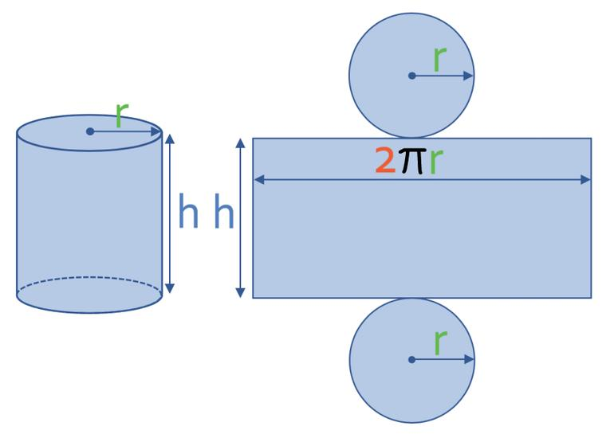
A cylinder's net consists of:
- Two equal circles.
- One rectangle whose dimensions are $2πr$ and $h$.
The rectangle's area equals the curved surface area:
$$A_{\text{rectangle}}=2πrh$$
The complete net has area $2πrh+2πr^{2}$, equal to the total surface area of the closed cylinder.

Worked Examples
# Source: AI Source: Provided by: [Data Path: Persons Table -> ID Column: 1, Name_En Column: Motasem Essam] -> From: [ChatGPT] on [7/25/2026]
Example 1: Calculating the Volume
A cylinder has a radius of $4\text{ cm}$ and a height of $10\text{ cm}$. Find its volume.
Step 1 — Write the formula.
$$V=πr^{2}h$$
Step 2 — Substitute the values.
$$V=π{\left(4\right)}^{2}\left(10\right)$$
$$V=160π$$
Answer:
$$\boxed{V≈502.65{\text{ cm}}^{3}}$$
Example 2: Calculating the Curved Surface Area
A cylinder has a radius of $3\text{ cm}$ and a height of $8\text{ cm}$. Find its curved surface area.
$$A_{L}=2πrh$$
$$A_{L}=2π\left(3\right)\left(8\right)=48π$$
Answer:
$$\boxed{A_{L}≈150.80{\text{ cm}}^{2}}$$
Example 3: Calculating the Total Surface Area
A closed cylinder has a radius of $5\text{ cm}$ and a height of $12\text{ cm}$.
Step 1 — Apply the formula.
$$A_{T}=2πr\left(h+r\right)$$
Step 2 — Substitute the values.
$$A_{T}=2π\left(5\right)\left(12+5\right)$$
$$A_{T}=170π$$
Answer:
$$\boxed{A_{T}≈534.07{\text{ cm}}^{2}}$$
Example 4: Finding the Height from the Volume
A cylinder has a volume of $200π{\text{ cm}}^{3}$ and a radius of $5\text{ cm}$. Find its height.
$$V=πr^{2}h$$
Substitute the known values:
$$200π=π{\left(5\right)}^{2}h$$
$$200π=25πh$$
Divide both sides by $25π$:
$$\boxed{h=8\text{ cm}}$$

Constructing a Cylinder

Geometric Instruments
# Source: AI Source: Provided by: [Data Path: Persons Table -> ID Column: 1, Name_En Column: Motasem Essam] -> From: [ChatGPT] on [7/25/2026]
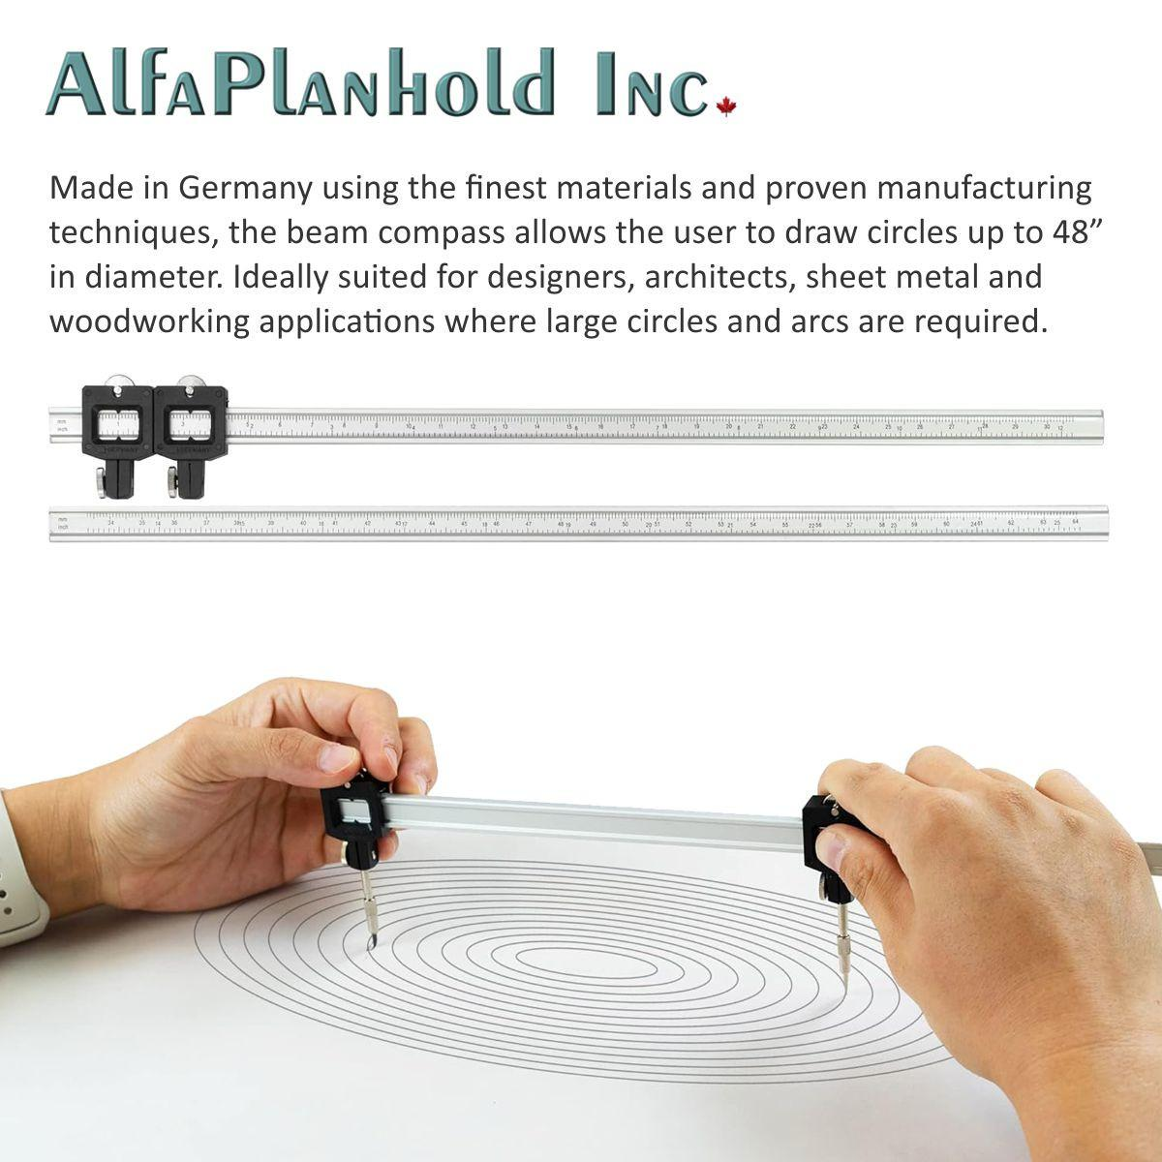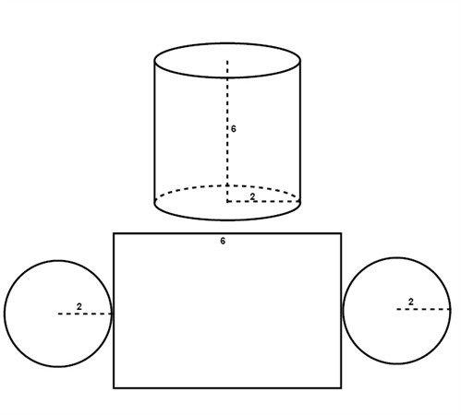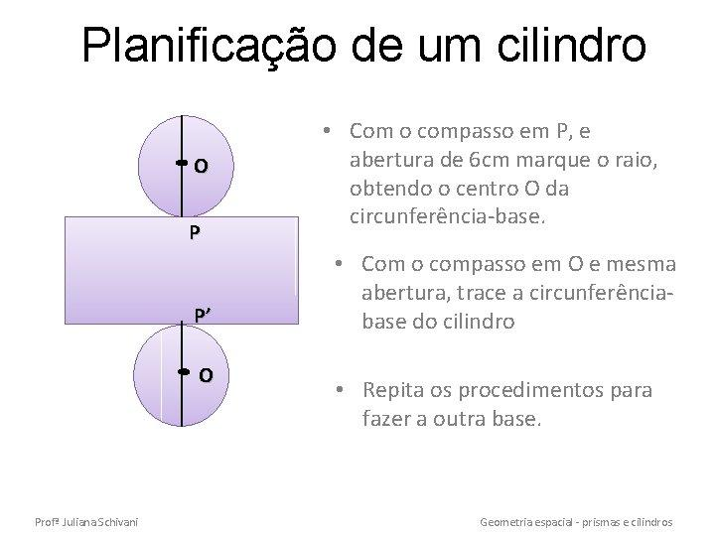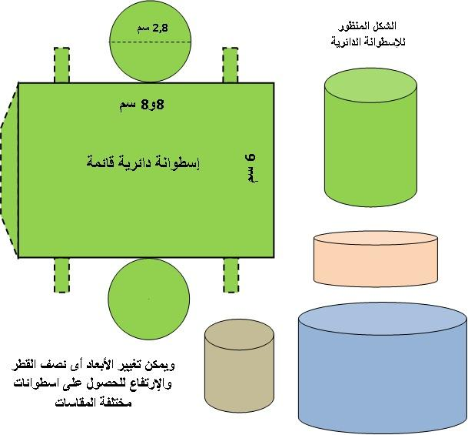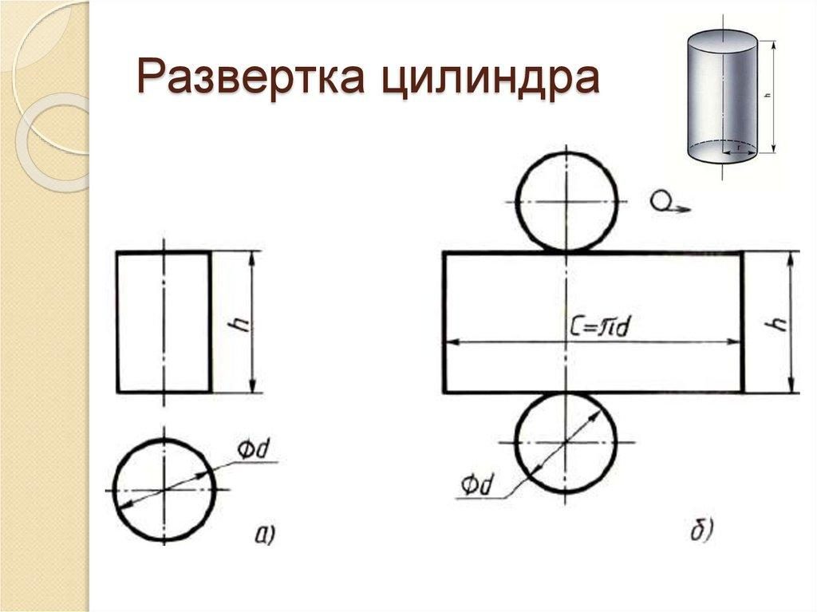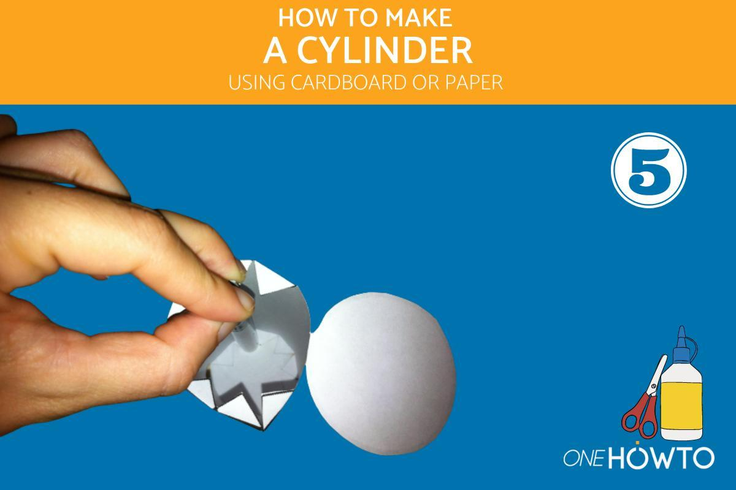
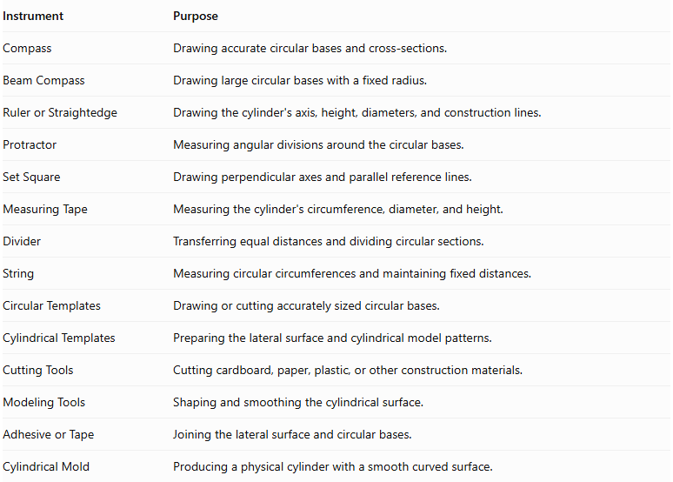
Instrument | Purpose
Compass | Drawing accurate circular bases and cross-sections.
Beam Compass | Drawing large circular bases with a fixed radius.
Ruler or Straightedge | Drawing the cylinder's axis, height, diameters, and construction lines.
Protractor | Measuring angular divisions around the circular bases.
Set Square | Drawing perpendicular axes and parallel reference lines.
Measuring Tape | Measuring the cylinder's circumference, diameter, and height.
Divider | Transferring equal distances and dividing circular sections.
String | Measuring circular circumferences and maintaining fixed distances.
Circular Templates | Drawing or cutting accurately sized circular bases.
Cylindrical Templates | Preparing the lateral surface and cylindrical model patterns.
Cutting Tools | Cutting cardboard, paper, plastic, or other construction materials.
Modeling Tools | Shaping and smoothing the cylindrical surface.
Adhesive or Tape | Joining the lateral surface and circular bases.
Cylindrical Mold | Producing a physical cylinder with a smooth curved surface.

Instrument-Based Construction Procedures

Method 1: Constructing a Right Circular Cylinder Using Circular Bases and a Rectangular Lateral Surface
# Source: AI Source: Provided by: [Data Path: Persons Table -> ID Column: 1, Name_En Column: Motasem Essam] -> From: [ChatGPT] on [7/25/2026]
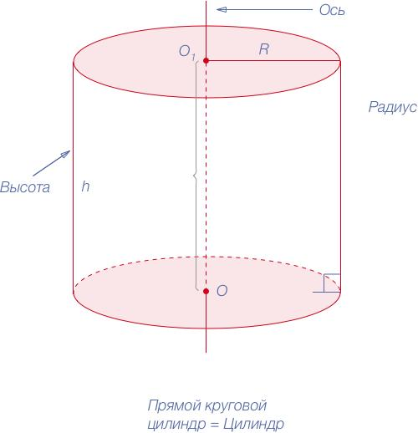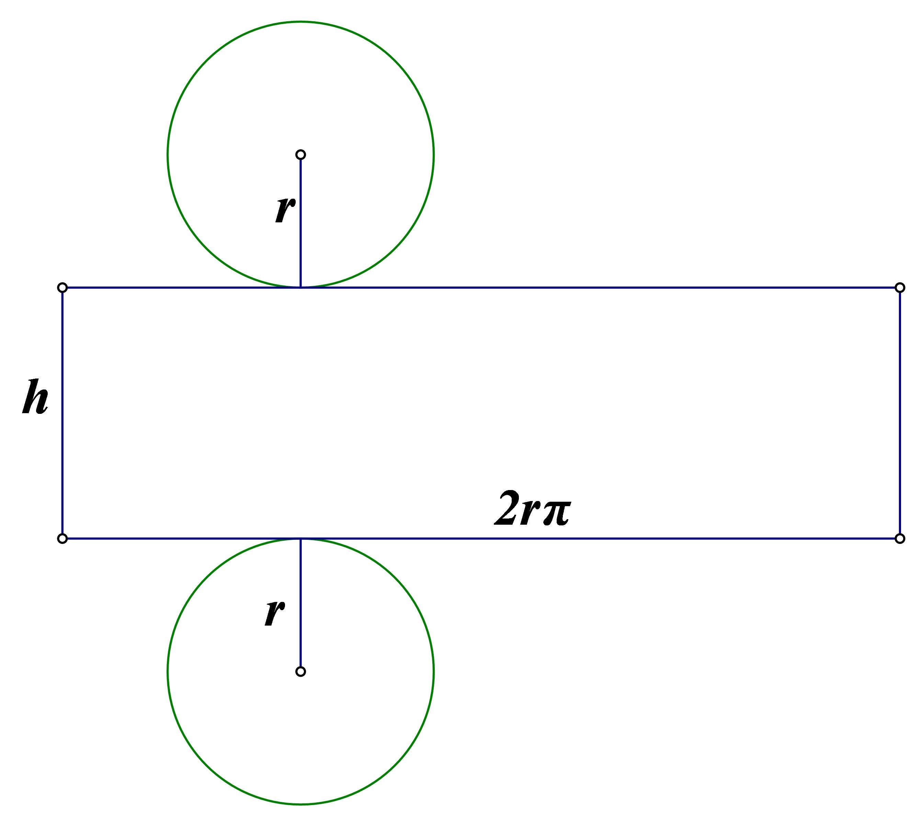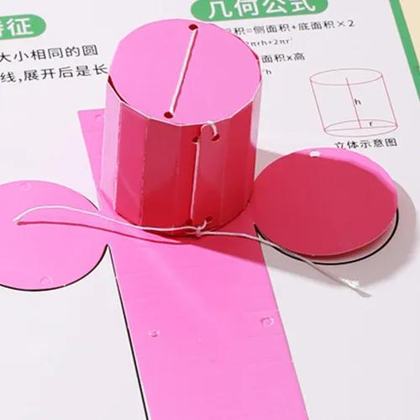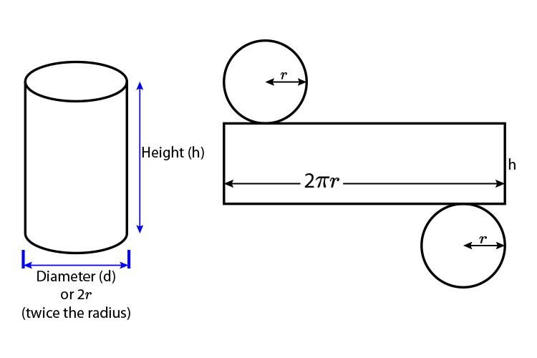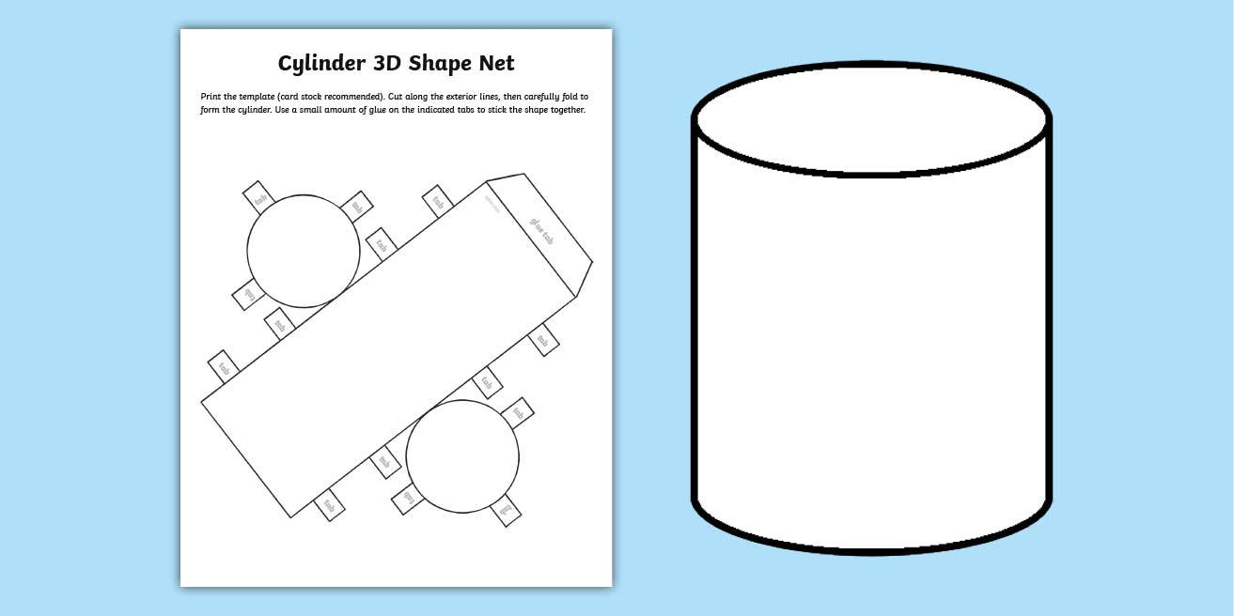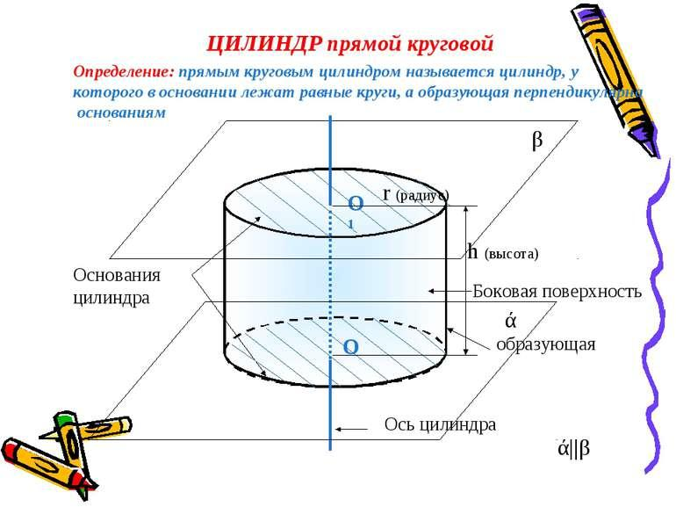
- Determine the required cylinder radius $r$ and height $h$.
- Draw a vertical line segment representing the cylinder's height.
- Mark the upper and lower endpoints as the centers of the two circular bases.
- Draw two equal circles using a compass, with radius $r$.
- Draw the lateral surface as a rectangle with:
- Length equal to the circumference of the circular base.
- Width equal to the cylinder's height.
- Calculate the rectangle's length using $C=2πr$.
- Cut out the two circular bases and the rectangular lateral surface.
- Roll the rectangle into a cylindrical shape.
- Join its two vertical edges using adhesive or tape.
- Attach one circular base to each open end.
- Align the two circular bases so their centers lie along the same axis.
- Verify the cylinder's height, diameter, and circular base alignment.

Method 2: Constructing a Right Circular Cylinder Using Stacked Circular Sections
# Source: AI Source: Provided by: [Data Path: Persons Table -> ID Column: 1, Name_En Column: Motasem Essam] -> From: [ChatGPT] on [7/25/2026]
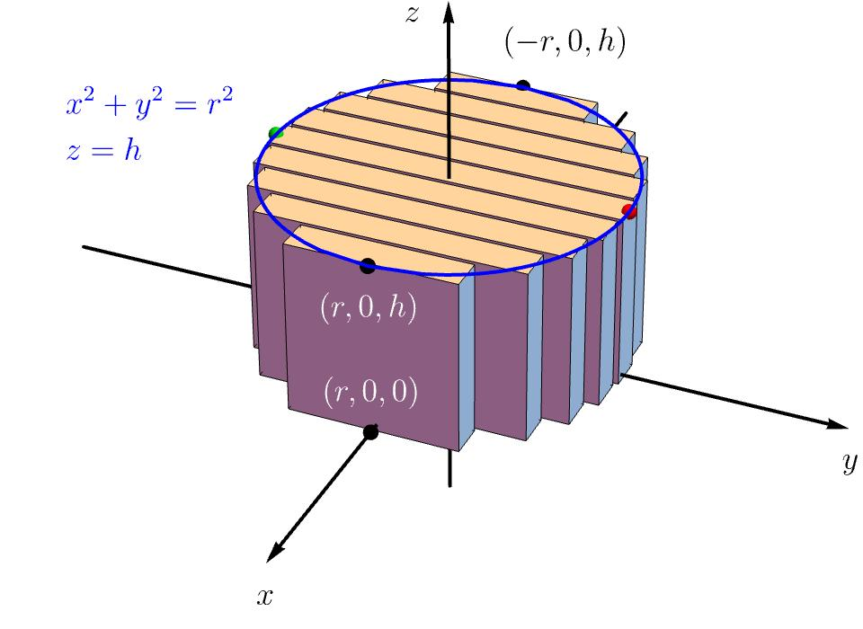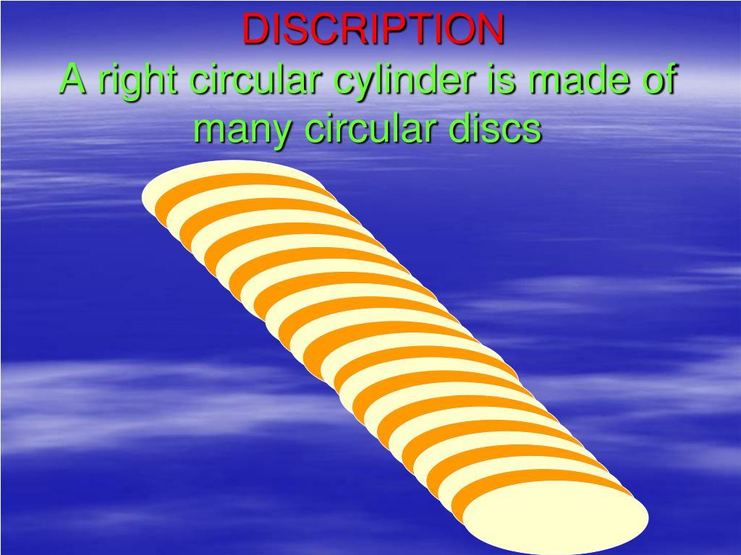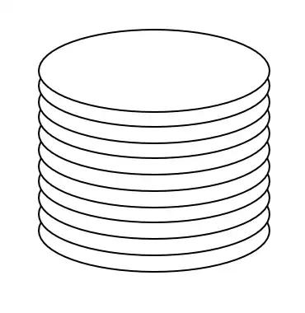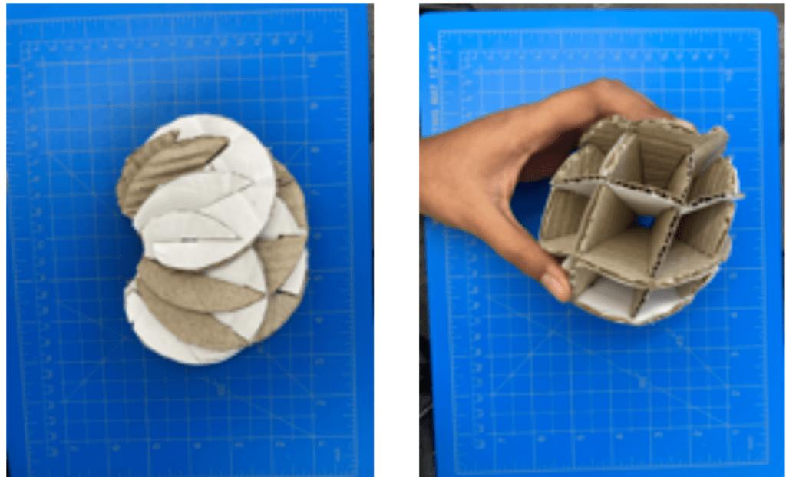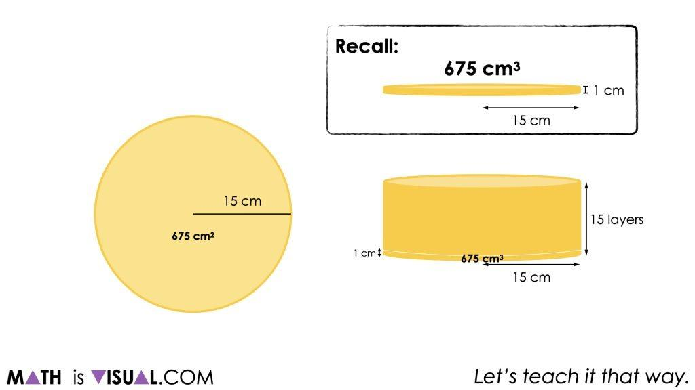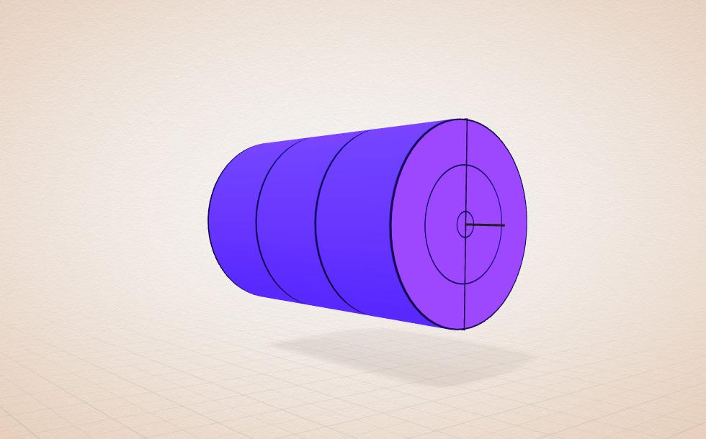
- Determine the required cylinder radius $r$ and height $h$.
- Draw a vertical axis representing the cylinder's height.
- Divide the height into several equal intervals using a ruler.
- Mark the center of each circular section along the axis.
- Draw perpendicular reference lines through the marked centers using a set square.
- Draw equal circles at each center using a compass.
- Cut the circular sections from cardboard, foam, or another suitable material.
- Stack the circular sections along the central axis.
- Align all circles so their centers coincide with the axis.
- Join the sections using adhesive or a central support.
- Smooth the outer boundary to produce a continuous cylindrical surface.
- Attach or reinforce the top and bottom circular bases.

Method 3: Constructing an Oblique Circular Cylinder
# Source: AI Source: Provided by: [Data Path: Persons Table -> ID Column: 1, Name_En Column: Motasem Essam] -> From: [ChatGPT] on [7/25/2026]
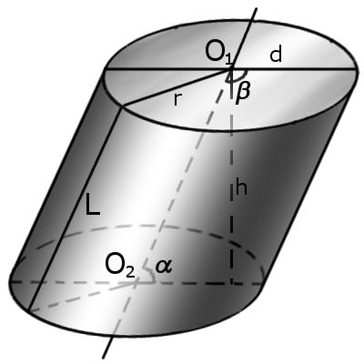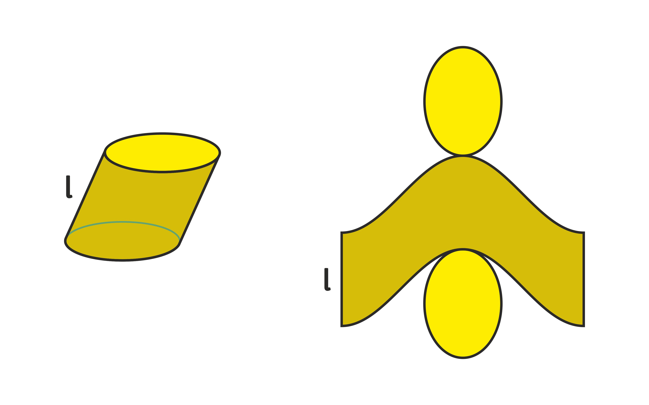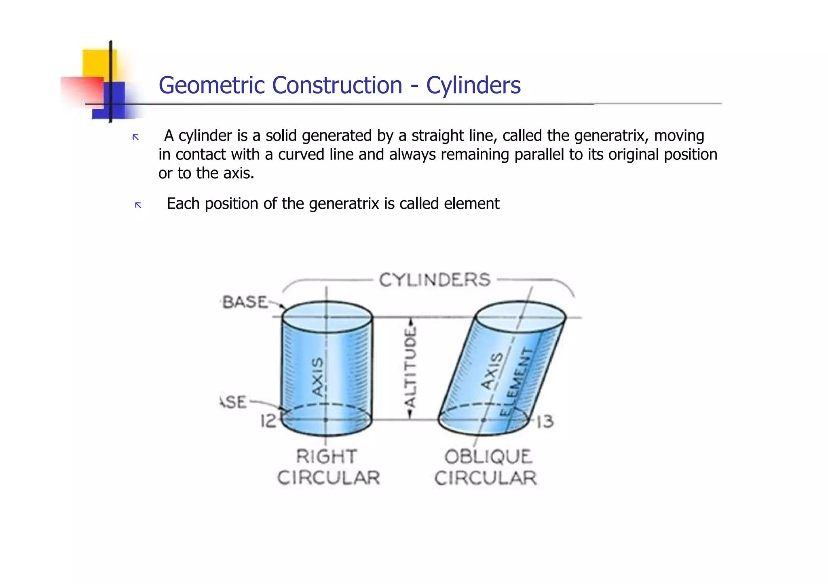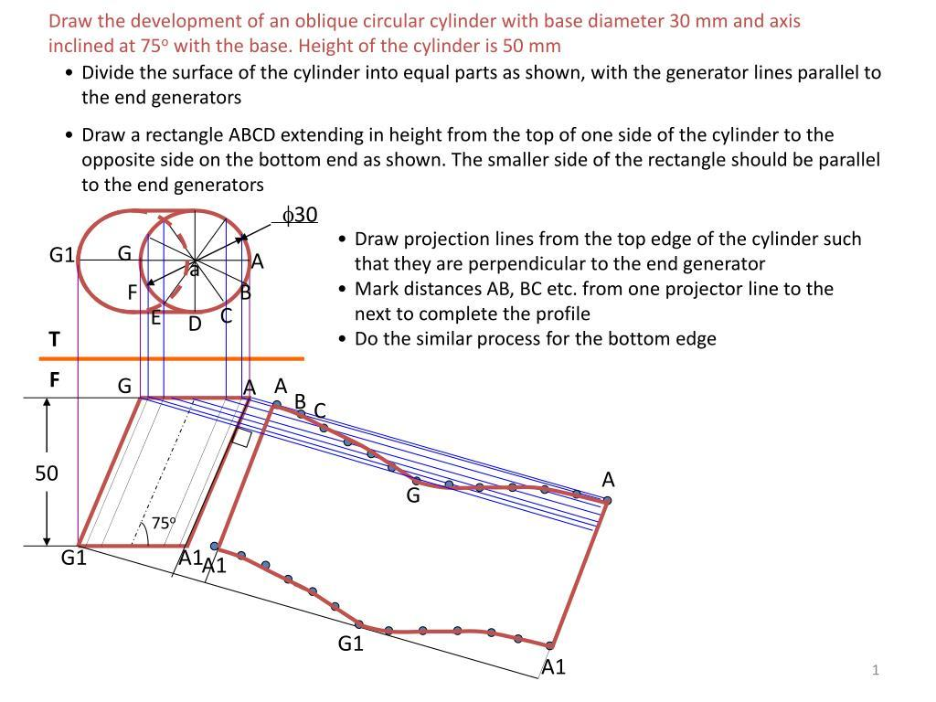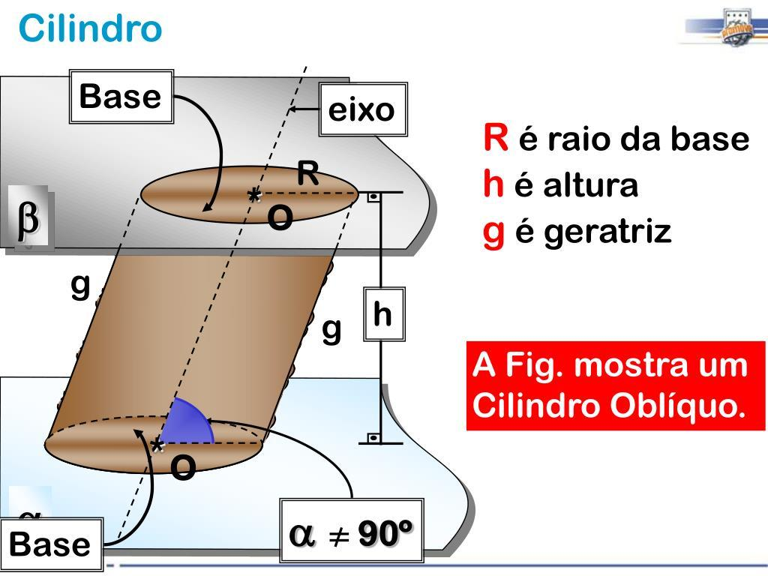
- Determine the required base radius and perpendicular distance between the base planes.
- Draw two parallel reference lines representing the planes of the circular bases.
- Mark the centers of the two bases at different horizontal positions to establish the inclined axis.
- Draw equal circular bases using a compass or circular templates.
- Ensure that both circular bases lie in parallel planes.
- Divide the circular bases into equal angular sections using a protractor and compass.
- Mark corresponding division points on both bases.
- Connect corresponding points using straight reference lines representing the lateral elements.
- Prepare the lateral surface pattern using the measured lengths of the corresponding elements.
- Cut the lateral pattern and circular bases from suitable material.
- Join the lateral surface around the two circular bases.
- Check that the resulting cylinder has parallel circular bases and an inclined axis.

Method 4: Constructing a Cylinder Using a Cylindrical Mold
# Source: AI Source: Provided by: [Data Path: Persons Table -> ID Column: 1, Name_En Column: Motasem Essam] -> From: [ChatGPT] on [7/25/2026]
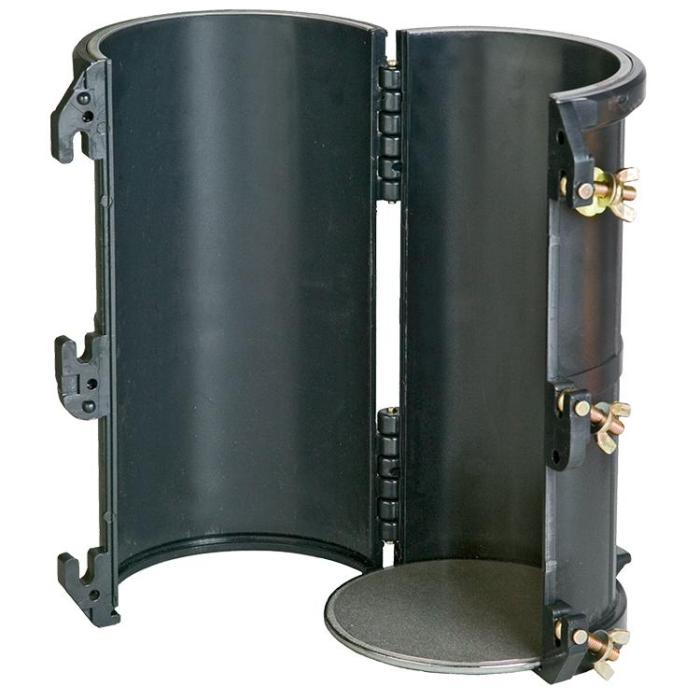
- Determine the required cylinder radius and height.
- Prepare a cylindrical mold with the required internal dimensions.
- Verify the mold's diameter and height using measuring instruments.
- Position the mold vertically or in the required orientation.
- Prepare a suitable modeling material.
- Fill the mold with the material, ensuring that it occupies the intended cylindrical space.
- Allow the material to set or harden.
- Remove the cylinder from the mold, if the mold is designed to be removable.
- Smooth the curved lateral surface and circular ends.
- Measure the finished cylinder to verify its dimensions.

Method 5: Constructing a Cylinder Using a Rolled Rectangular Sheet
# Source: AI Source: Provided by: [Data Path: Persons Table -> ID Column: 1, Name_En Column: Motasem Essam] -> From: [ChatGPT] on [7/25/2026]
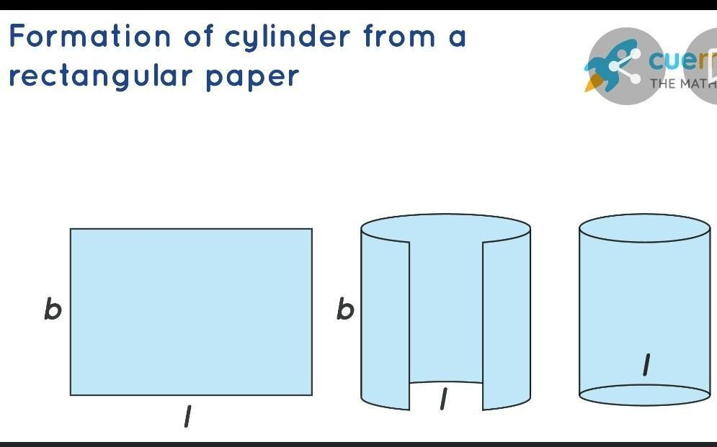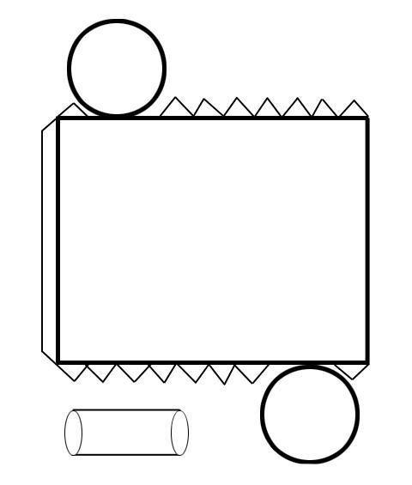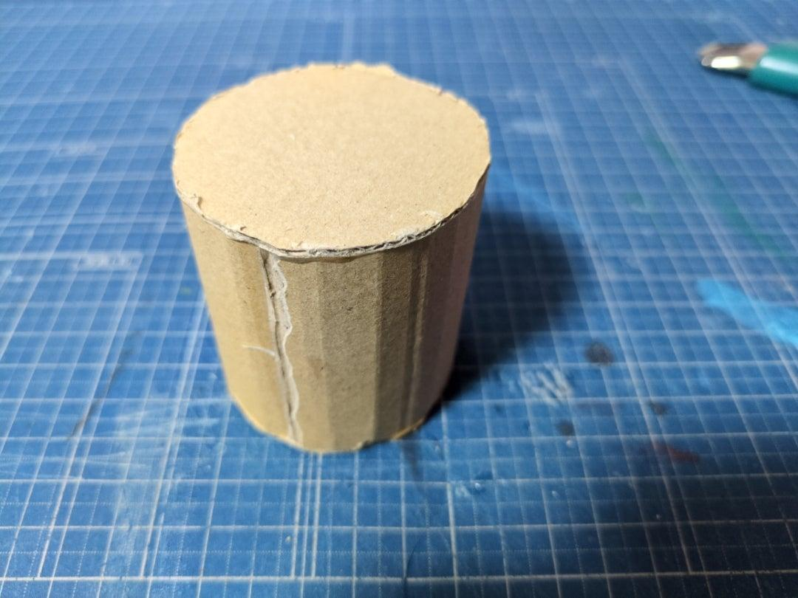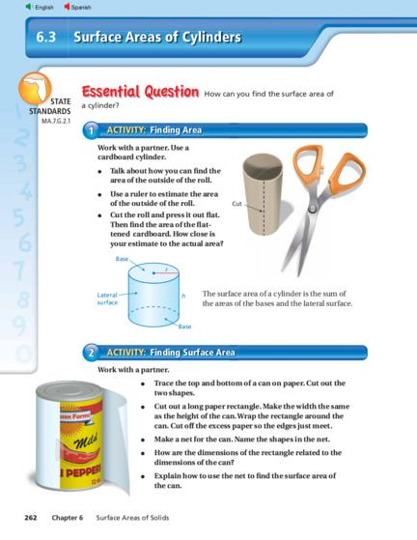
- Determine the required cylinder radius $r$ and height $h$.
- Calculate the circular base circumference:
$$C=2πr$$
- Draw a rectangle with length $C$ and width $h$.
- Mark the two opposite vertical edges of the rectangle.
- Cut out the rectangular sheet.
- Roll the sheet until its two vertical edges meet.
- Join the edges using adhesive or tape.
- Draw two equal circles using a compass.
- Cut out the circular bases.
- Attach one circle to each open end.
- Align the bases with the cylindrical lateral surface.
- Verify the finished cylinder's dimensions and shape.

Method 6: Constructing the Development of a Cylinder
# Source: AI Source: Provided by: [Data Path: Persons Table -> ID Column: 1, Name_En Column: Motasem Essam] -> From: [ChatGPT] on [7/25/2026]
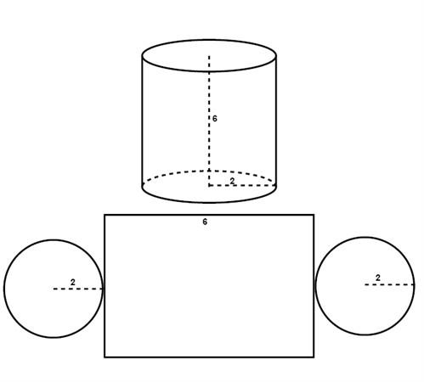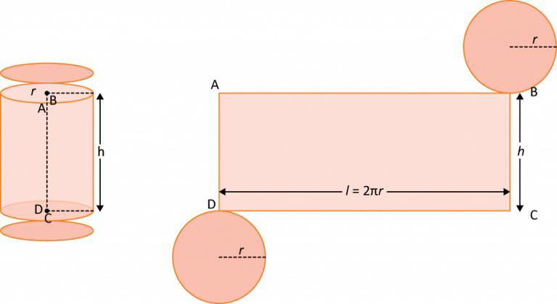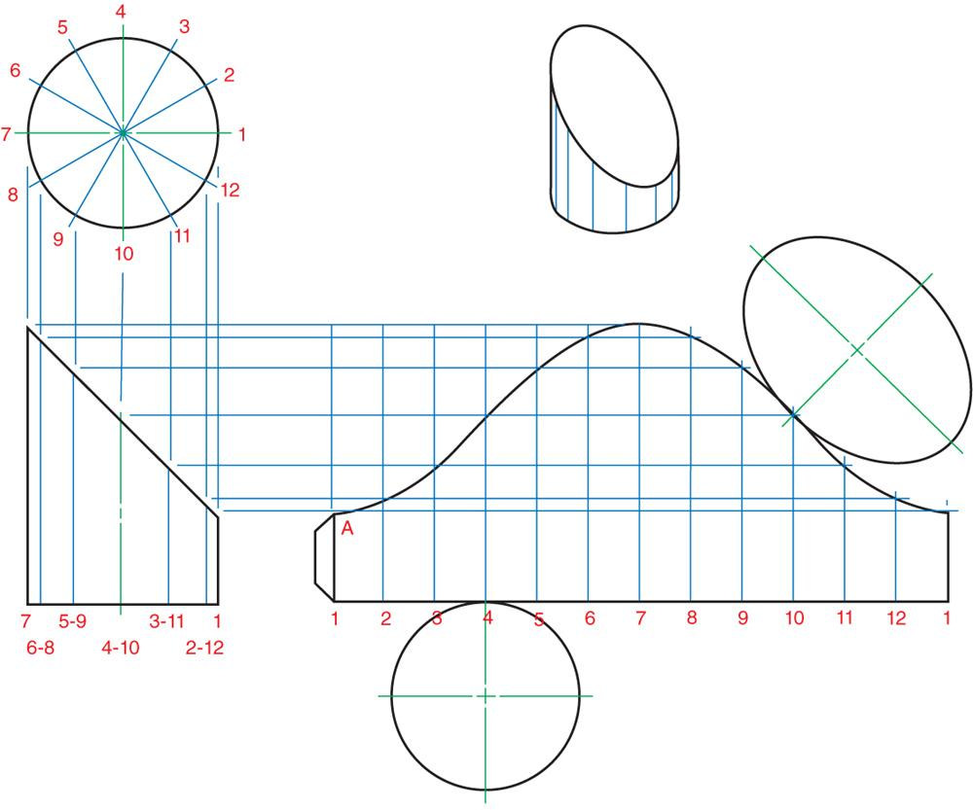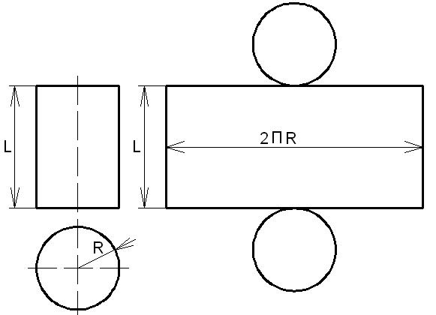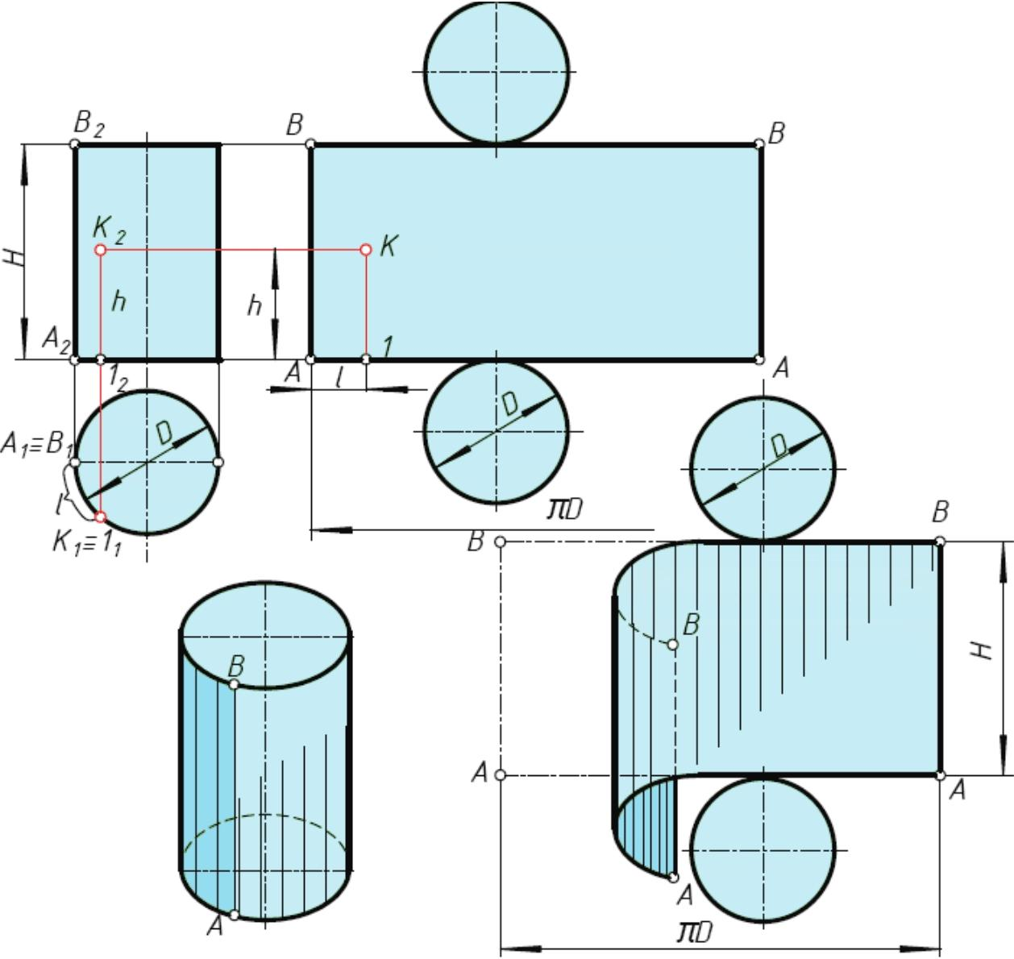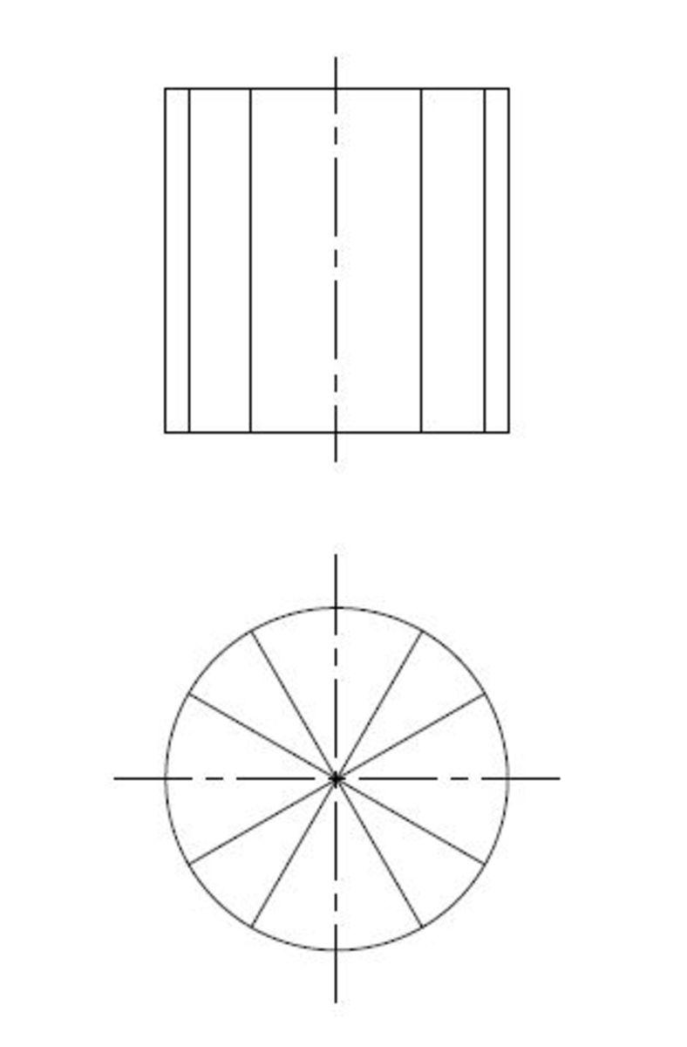
- Draw the top view of the cylinder as a circle.
- Draw the front view showing the cylinder's height and diameter.
- Divide the circular base into 12 or more equal angular sections using a protractor.
- Number the division points consecutively.
- Draw a horizontal stretch-out line with a length equal to the base circumference.
- Divide the stretch-out line into the same number of equal sections.
- Draw perpendicular lines at the division points.
- Set the vertical height of the development equal to the cylinder's height.
- Join the corresponding boundaries to complete the rectangular lateral development.
- Draw two circles equal to the cylinder's bases.
- Cut out the complete development.
- Roll the rectangular portion and attach the circular bases to assemble the cylinder.
The lateral development of a right circular cylinder is a rectangle whose length equals the base circumference and whose width equals the cylinder height.

Method 7: Constructing a Truncated Cylinder
# Source: AI Source: Provided by: [Data Path: Persons Table -> ID Column: 1, Name_En Column: Motasem Essam] -> From: [ChatGPT] on [7/25/2026]
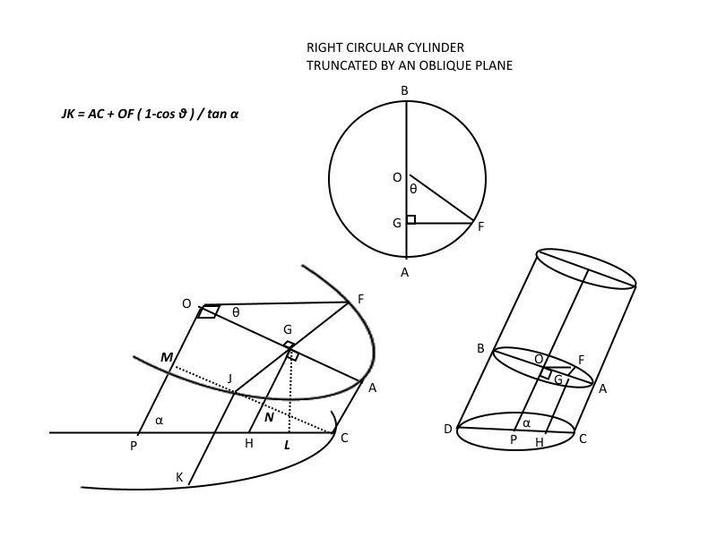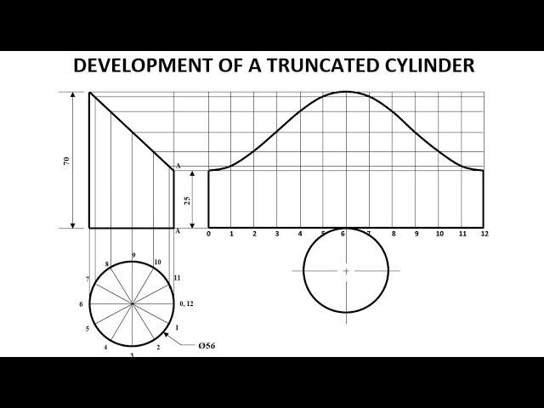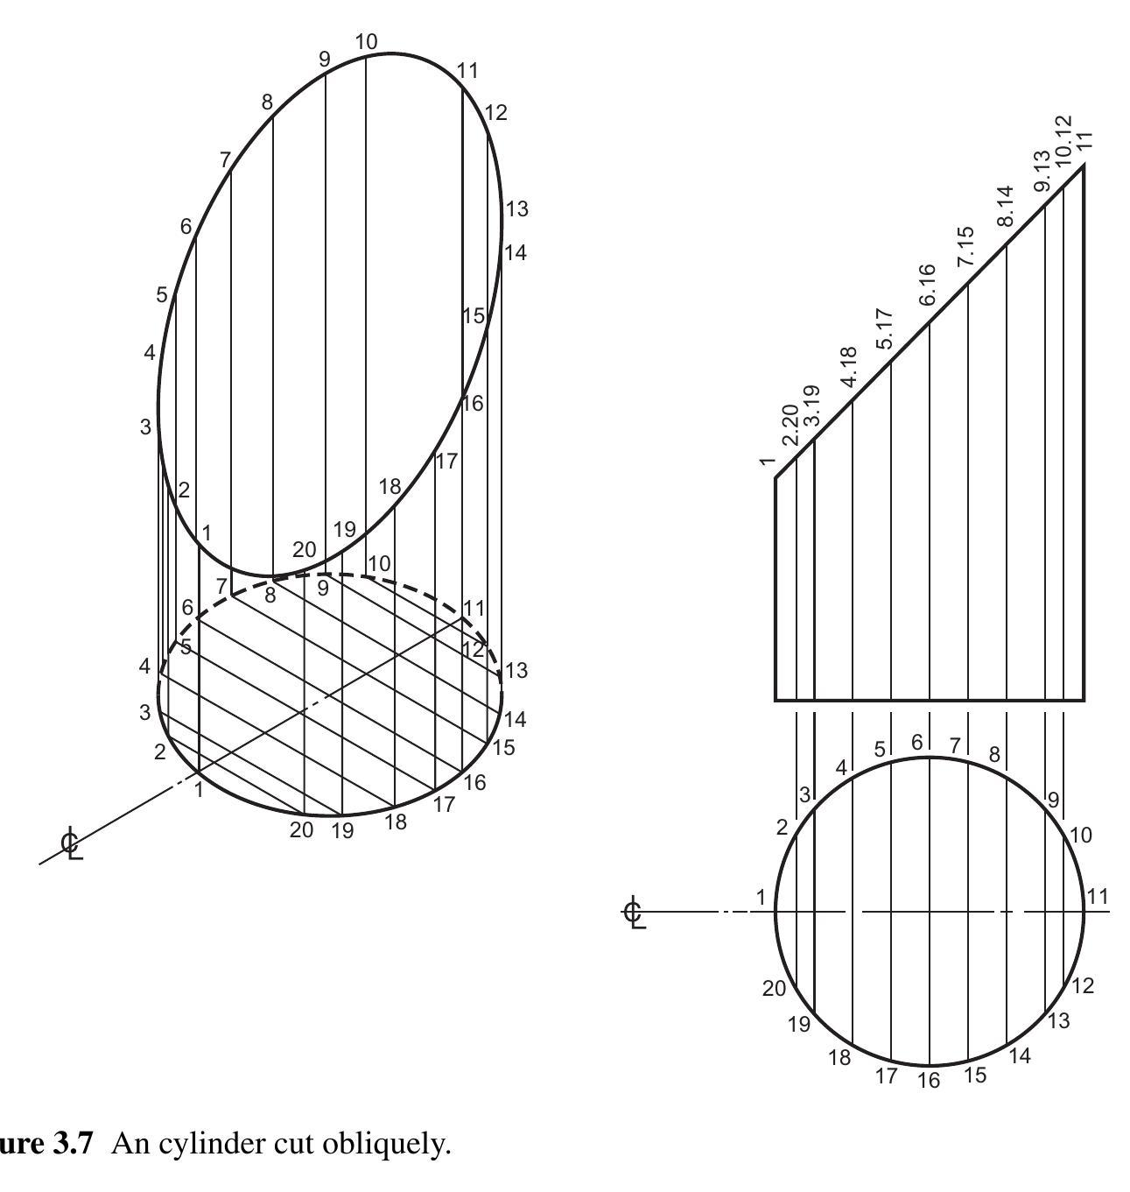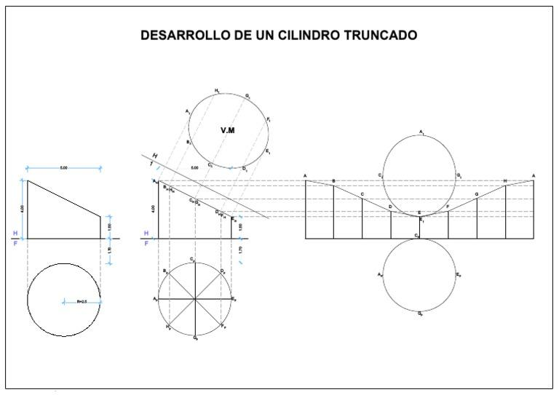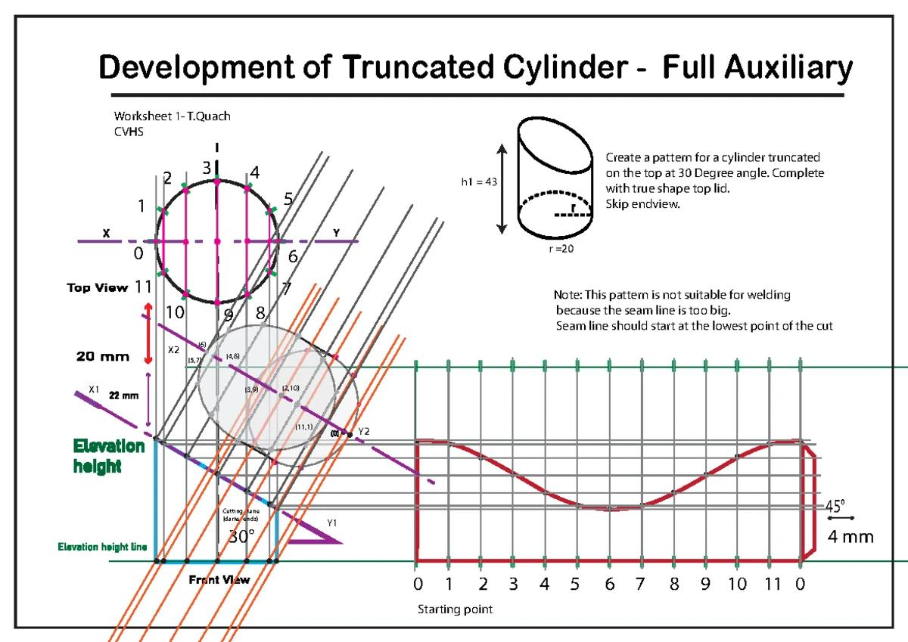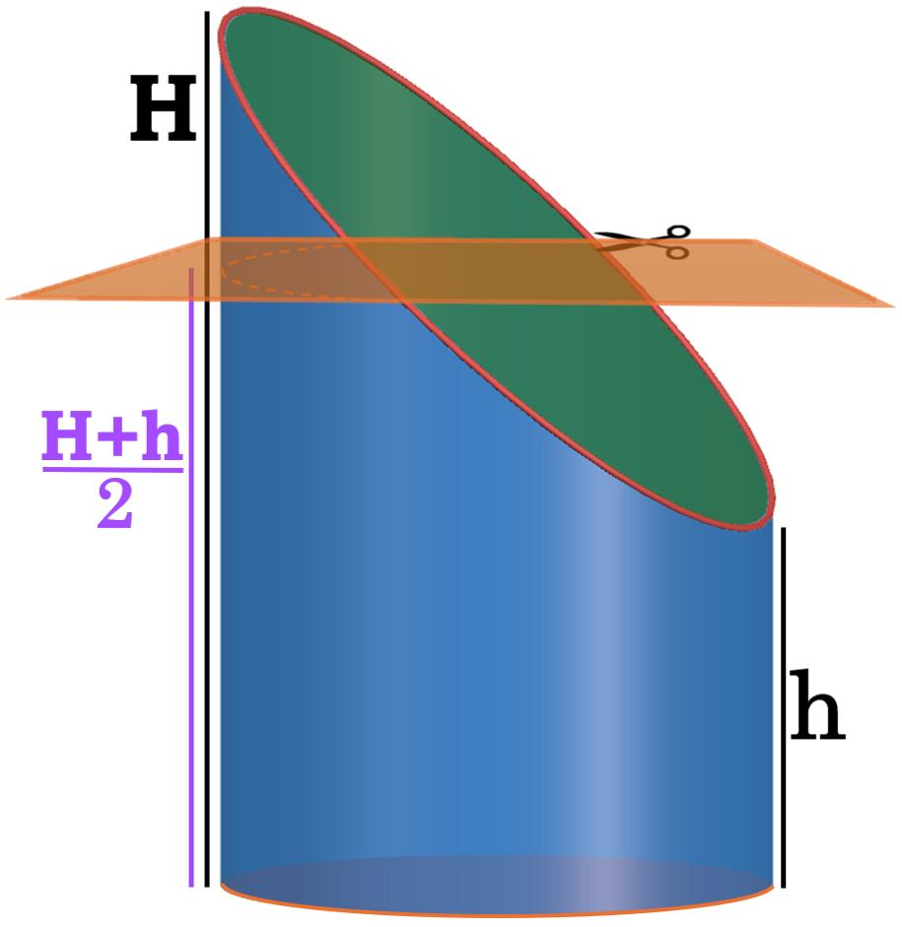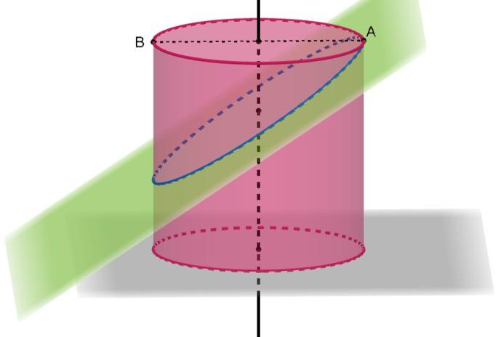
- Construct the required right circular cylinder using a compass, ruler, and set square.
- Draw its front and top views.
- Divide the circular top view into 12 or more equal sections.
- Number the division points around the circumference.
- Project the division points onto the front view.
- Draw the required inclined cutting line or plane in the front view.
- Mark the intersection points between the cutting plane and the projected lateral elements.
- Transfer the measured heights of these points to the corresponding positions on the cylinder's lateral development.
- Join the transferred points using a smooth curve.
- Cut the developed pattern along the resulting boundary.
- Assemble the lateral surface and attach the required base.
- Verify the inclined or irregular boundary against the original construction.
The division-and-projection procedure is used in engineering drawing to develop cylinders cut by inclined planes.
Construction note: These methods cover right circular cylinders, oblique circular cylinders, and truncated cylinders. The construction of the lateral surface and its development depends on the cylinder's orientation and cutting geometry.

Types of Cylinders

Right Circular Cylinder
# Source: AI Source: Provided by: [Data Path: Persons Table -> ID Column: 1, Name_En Column: Motasem Essam] -> From: [ChatGPT] on [7/25/2026]
The circular bases are parallel, and the axis is perpendicular to them. The lateral surface can be unrolled into a rectangle, so $A_{L}=2πrh$.
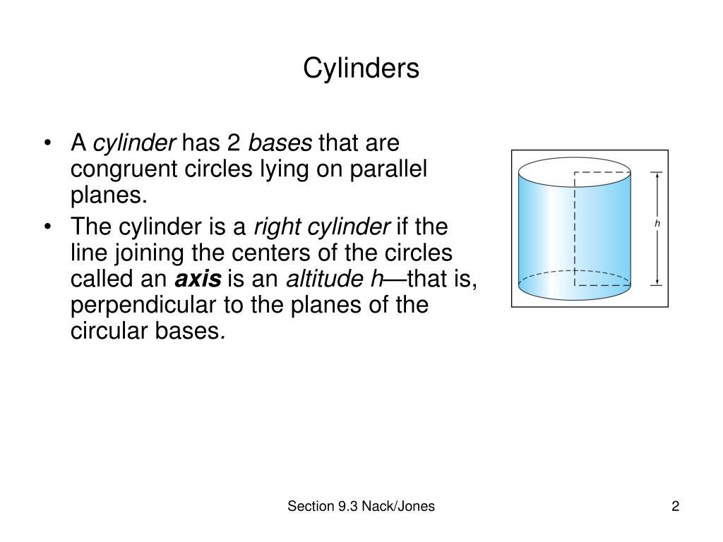

Oblique Circular Cylinder
# Source: AI Source: Provided by: [Data Path: Persons Table -> ID Column: 1, Name_En Column: Motasem Essam] -> From: [ChatGPT] on [7/25/2026]
The circular bases remain parallel, but the axis is inclined rather than perpendicular to the bases. The height is still the perpendicular distance between the base planes.
For both right and oblique circular cylinders, the volume is $V=πr^{2}h$, where $h$ is the perpendicular height. The simple lateral surface area formula $2πrh$ applies to the right circular cylinder, not generally to an oblique cylinder.
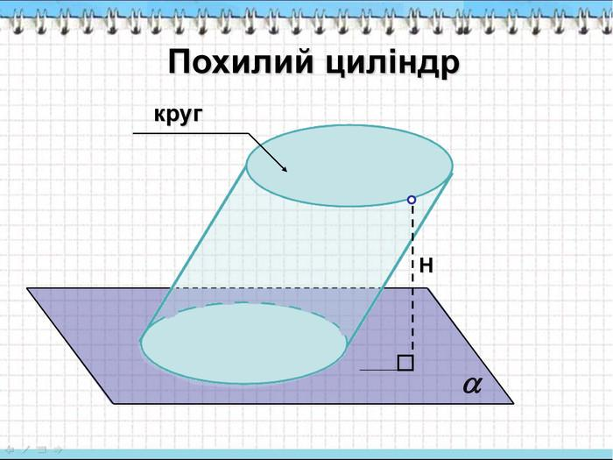

Comparison with Related Geometric Shapes
# Source: AI Source: Provided by: [Data Path: Persons Table -> ID Column: 1, Name_En Column: Motasem Essam] -> From: [ChatGPT] on [7/25/2026]
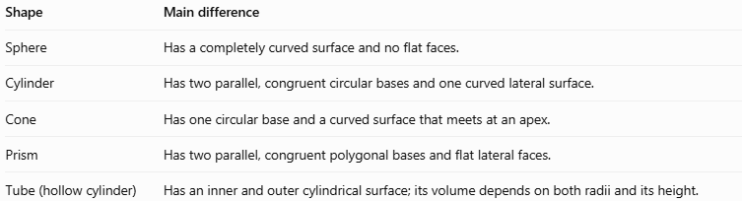
Shape | Main difference
Sphere | Has a completely curved surface and no flat faces.
Cylinder | Has two parallel, congruent circular bases and one curved lateral surface.
Cone | Has one circular base and a curved surface that meets at an apex.
Prism | Has two parallel, congruent polygonal bases and flat lateral faces.
Tube (hollow cylinder) | Has an inner and outer cylindrical surface; its volume depends on both radii and its height.

Applications of Cylinders
# Source: AI Source: Provided by: [Data Path: Persons Table -> ID Column: 1, Name_En Column: Motasem Essam] -> From: [ChatGPT] on [7/25/2026]
- Containers: Cans, jars, drums, and storage tanks.
- Engineering: Pistons, hydraulic cylinders, shafts, and machine components.
- Construction: Columns, cylindrical supports, and concrete pipes.
- Plumbing: Water pipes and drainage systems.
- Mathematics: Calculating volume, surface area, and geometric transformations.
- Manufacturing: Designing cylindrical components and estimating material requirements.

Key Points
# Source: AI Source: Provided by: [Data Path: Persons Table -> ID Column: 1, Name_En Column: Motasem Essam] -> From: [ChatGPT] on [7/25/2026]
- A cylinder has two congruent, parallel circular bases and a curved lateral surface.
- A right circular cylinder has an axis perpendicular to its bases.
- The radius is half the diameter: $d=2r$.
- The volume is $V=πr^{2}h$.
- The curved surface area of a right circular cylinder is $A_{L}=2πrh$.
- The total surface area of a closed right circular cylinder is $A_{T}=2πr\left(h+r\right)$.
- The cylinder's net consists of two circles and one rectangle.
- An oblique cylinder's height is measured perpendicular to its bases, not along its inclined axis.

Conclusion
# Source: AI Source: Provided by: [Data Path: Persons Table -> ID Column: 1, Name_En Column: Motasem Essam] -> From: [ChatGPT] on [7/25/2026]
A cylinder is a fundamental solid with curved surfaces, characterized by two equal, parallel bases connected by a curved lateral surface. Its volume and surface area formulas make it useful in geometry, engineering, construction, and everyday design. Understanding the difference between right and oblique cylinders is particularly important when choosing the correct formulas.

